Unit 1 Genocide Calendar
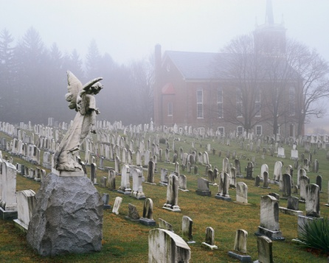
Lecture on Citation #1 – August 21
Lecture on Genocide #2 – August 23
Watch video on Hotel Rwanda #4 – August 26-29
Watch video on Ghosts of Rwanda #5 – September 3-5
Watch video on The Armenian Genocide – September 18
Complete reading of The Sandcastle Girls #7 – September 25
Book discussion on The Sandcastle Girls – September 26-27
#1 through #10 submitted, graded, and returned – September 30
Outline and Question for essay #11 – October 3
Write and essay on Genocide #12 – October 4

